**Feature 6 – Enrolment Contract**

**As an** owner of the ‘Pinelands Music School’ **I want** a single lesson enrolment contract **so that** I can store the agreement terms of the student and teacher in a standardised format.

**Summary**

The enrolment contract form aims to capture all the information required to present a lesson agreement to BOTH teacher and student.

**Acceptance Criteria**

* Only Mika is authorised to access this page
* The student must be waiting for an enrolment contract – you must not be able to include the option of a student already holding a contract
* Start Date must be after the current date
* End Date must be after the start date.
* Lesson Type must be chosen
* If it is a new student, only one lesson per week will be offered
* If it is an old student, up to three lessons per week will be offered
* Lesson date must not be on a weekend and/or public holidays
* The lesson time must ONLY be between 9-5
* The teacher must be available depending on the date and time chosen
* For the second/third lesson, the previous lesson times and dates need to also be considered when determining teacher availability
* The teacher must be qualified to conduct the lesson type
* All fields must be filled to process the form – do not allow to proceed otherwise
* The information must be stored and returned to both associated teacher/student
* When the home button is clicked, it will reset the form and return to the main page

**Description**

Lesson type will be given as a drop down selection

Lesson duration will be given as a drop down selection

Lesson cost will be hardcoded depending on lesson duration

As these contracts will be sent to the teacher, only Mika is able to manage the enrolment contracts

The information will then be updated in the database for both teacher and student

For Enrolment Contract the most important field is choose student. Once a student is chosen, the lesson type, student status (new/old) and preferences will be filled out and hardcoded. All details must be filled out. Drop down menus will pre-dominantly be used to reduce human error.

If a student is an old student, up to three lessons can be filled out. At least one of these lessons MUST be filled. For a new student only one lesson can be offered and this MUST be filled.

Teacher availability information will need to constantly be updated depending on the fields chosen. Including considering the lessons chosen in the current form if there is more than one lesson.

Lesson cost will be hardcoded.

The cancel button will reset the form and the proceed button will return the following information to be stored in the database:

* Student Name
* Lesson Type
* Start Date
* End Date
* Lesson One Day
* Lesson One Time
* Lesson One Teacher
* Lesson One Duration
* Lesson One Cost
* Lesson Two Day
* Lesson Two Time
* Lesson Two Teacher
* Lesson Two Duration
* Lesson Two Cost
* Lesson Three Day
* Lesson Three Time
* Lesson Three Teacher
* Lesson Three Duration
* Lesson Three Cost

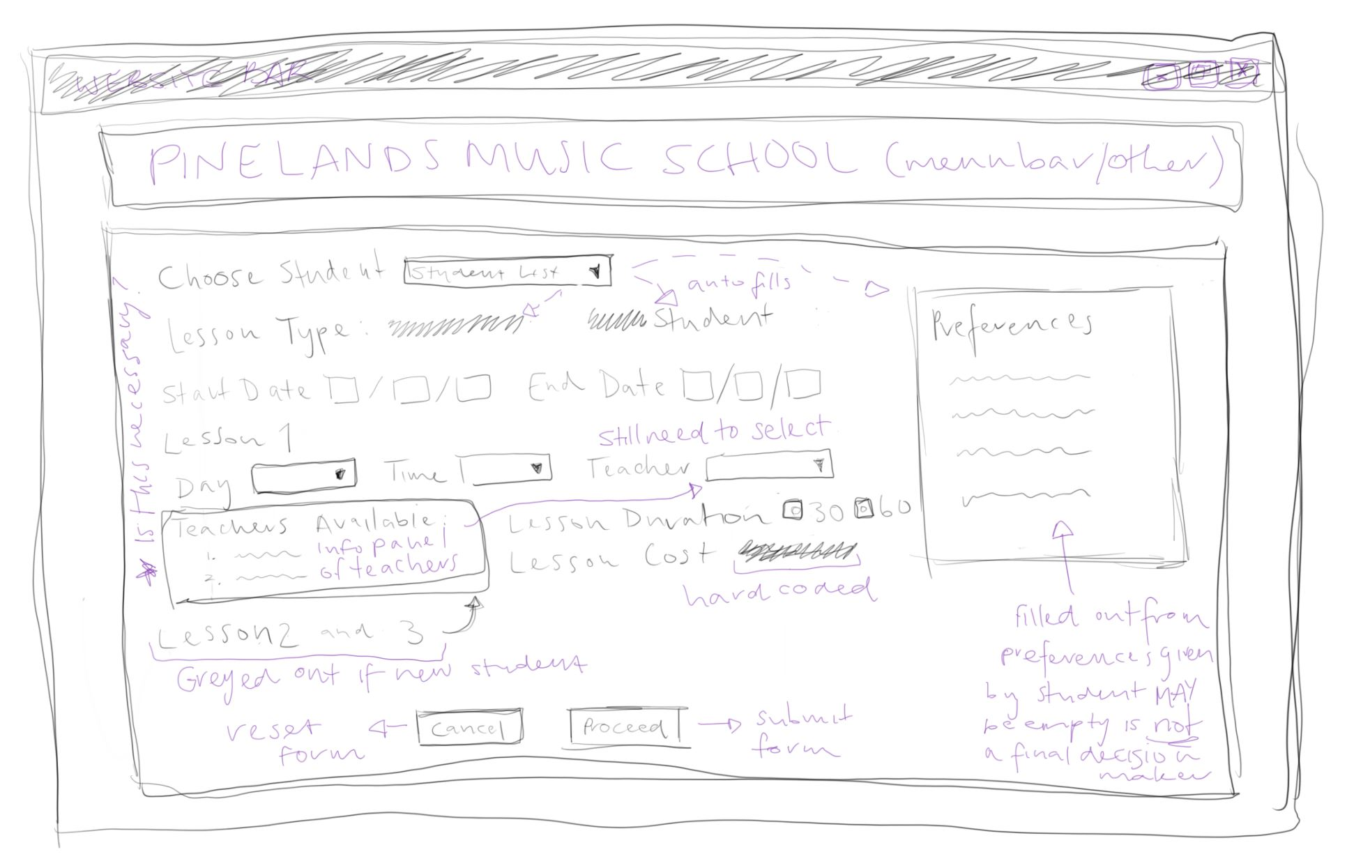**Potential Design Implementation**

**Initial Test Cases**